 Ideation Phase
Empathize & Discover
Date | 27 January 2026
Team ID | LTVIP2026TMIDS28465
Project Name | ShopEZ : One-Stop Shop for Online  Purchases
Maximum Marks | 4 Marks

Empathy Map Canvas:
An empathy map is a simple, easy-to-digest visual that captures knowledge about a user's behaviours, needs, and emotions.It helps teams develop deeper insight into the real people using the product. With ShopEZ, understanding both buyers (like Sarah) and sellers (like the bracelet vendor) is crucial to defining valuable and inclusive shopping experiences.

Example:
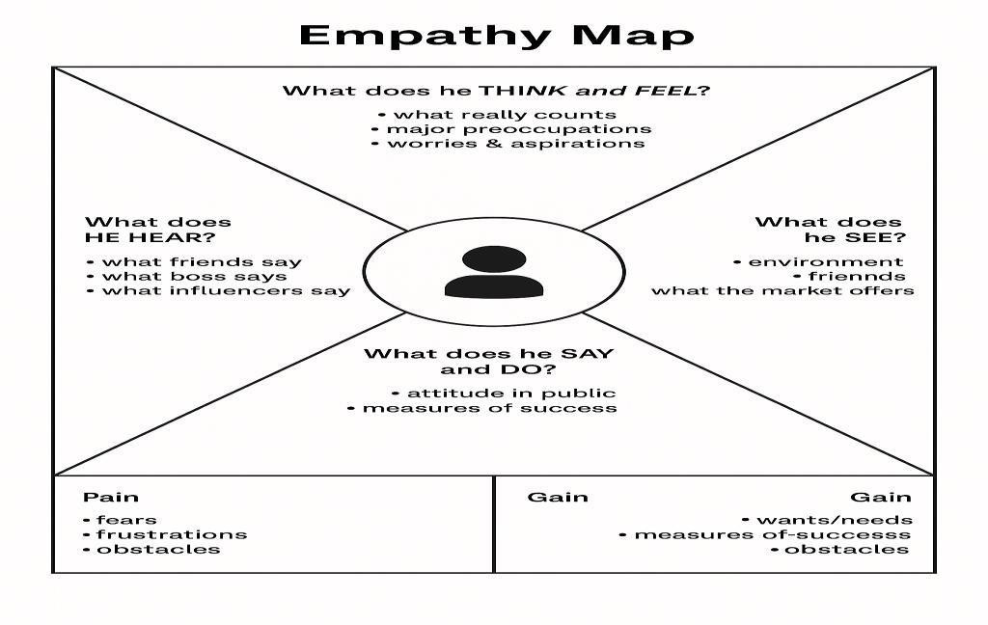

Example: Food Ordering & Delivery Application
